Academic Progress Template (APT) Reporting Template
This document houses two items: the APT rubric and an optional APT reporting template. One goal of providing the APT reporting template to assessment coordinators was to provide guidance regarding the key pieces of information evaluated in the APT rating process. Another intended goal of the reporting template was to streamline the report-writing process for coordinators. Specifically, the APT reporting template was designed to assist Assessment Coordinators, who are the primary APT report-writers in their respective programs, with the APT reporting process. Relatedly, we hope this template may be useful for programs when there is transition between Assessment Coordinators. Ideally, this template should be useful to new Assessment Coordinators if they want to learn more about their program’s assessment instruments and assessment process.
The APT template was developed to correspond to each section of the APT rubric. The APT rubric represents the criteria on which all APT reports are rated and was developed to align with JMU’s assessment cycle:

The APT rubric consists of 14 elements, each representing important features of the assessment cycle. Coordinators will notice that each of these 14 elements are represented in the APT reporting template. Headers of the template explicitly correspond to the rubric elements. The brief blurbs beneath each template header provide detail regarding the importance of the section and the types of information that might be beneficial to provide.
When determining which information to include in each template section, Assessment Coordinators may also reference the APT rubric (provided below). The descriptions provided in the APT rubric are the specific criteria on which APTs are rated; thus, by including this information in the APT, Assessment Coordinators can ensure that they are reporting the necessary information. The included tables are provided as examples of how programs might present information. The template may be used as is, or may be revised as necessary to meet the needs of your program.
Some additional resources for assessment coordinators:
- Example APTs can be found on the CARS website under the “Academic Degree Programs” section.
- For additional resources regarding JMU’s assessment cycle and the APT process, please see the CARS website.
- For support with completing your APT, please contact Program Assessment Support Services (PASS) at programassessment@jmu.edu.
- Though all elements of the APT are important, CARS specifically has dedicated resources to assisting programs with learning improvement (APT element 6A). If your program wishes to undergo a learning improvement project, please contact PASS.
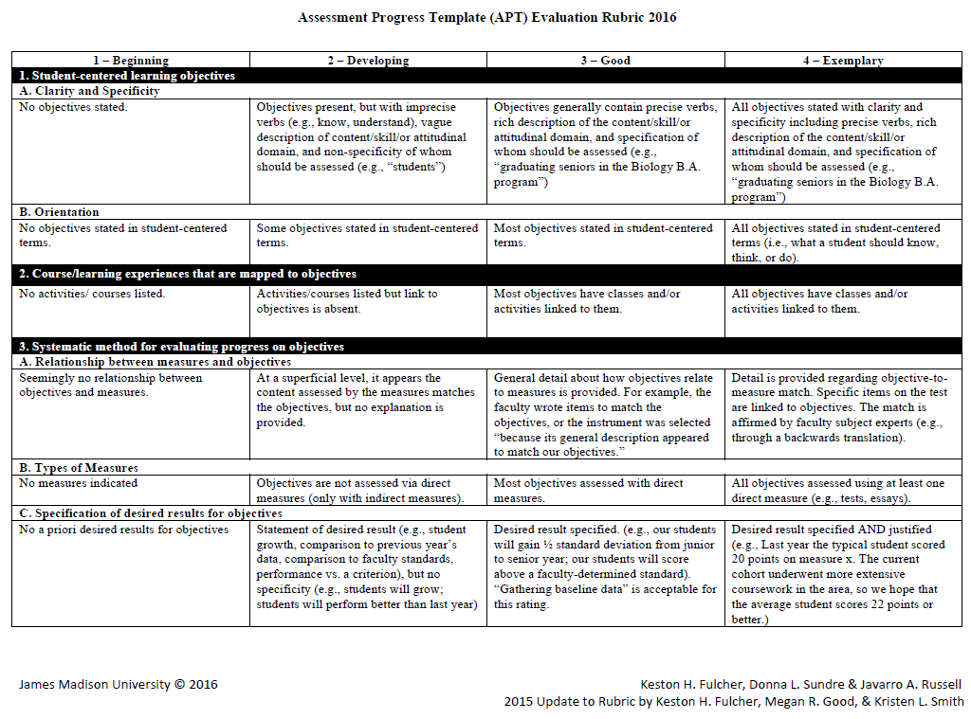
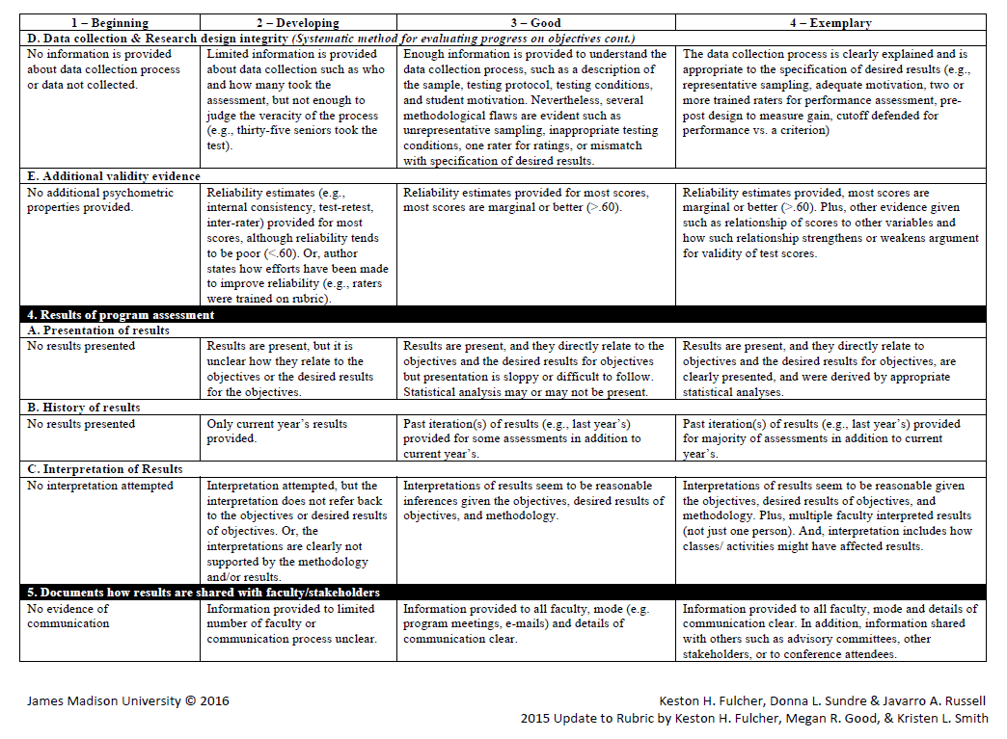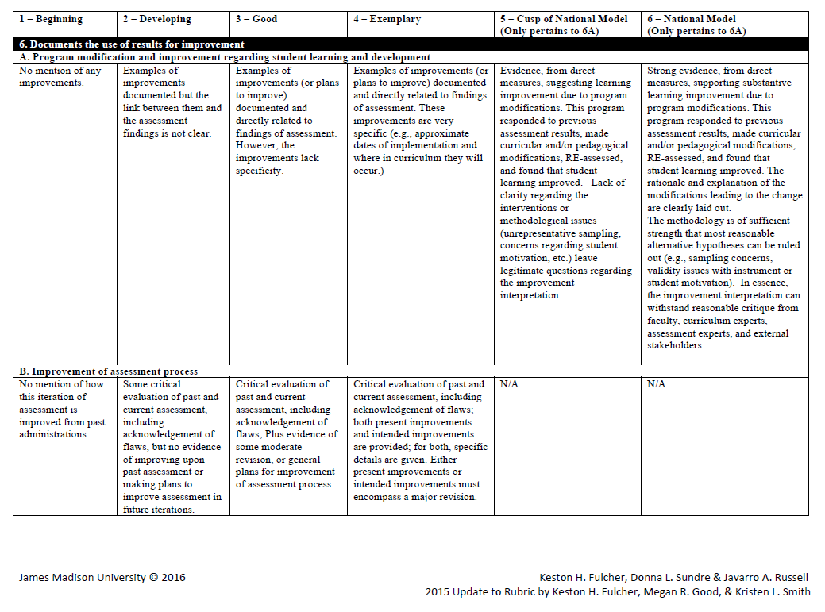

Academic Progress Template (APT) Reporting Template

Academic Degree Program:

Department Head:

Assessment Coordinator:

Student Learning Objectives (APT Element 1A & 1B)
Student learning objectives (SLOs) are statements indicating what students should know, think, or do as a result of participating in an academic degree program. SLOs should be student-centered and be written clearly with precise, measureable verbs. There is no set number of SLOs required for the APT.

Student Learning Objective
As a result of participating in the [academic degree program]curriculum, students graduating with a [degree type] in [academic degree program] will:

Course/learning Experiences (APT Element 2)
If students are expected to meet the stated SLOs, they must be provided with learning opportunities to assist them in meeting the SLO. Learning opportunities should be clearly linked to SLOs, and all SLOs should be covered by at least one learning opportunity. This is often referred to as program theory.
Two options for a curriculum map are provided below. You may choose either option for presenting your curriculum map.
Student learning objective | Courses/Experiences mapped to the objective

OR

 | Objective 1 | Objective 2 | Objective 3 | Objective 4 | Objective 5
Course/learning experience
Course/learning experience
Course/learning experience
Course/learning experience
*Note: for this table, programs may place an “X” into the appropriate intersecting boxes to indicate which course/learning experiences map to which objective(s). For either table, programs may specify coverage of the objective by course/learning experiences by placing a “1”, “2”, or “3,” etc., into the appropriate boxes, where a 1 indicates minimal coverage and higher scores indicate more coverage.
Additionally, coordinators may wish to provide more detail, such as course activities or assignments, to complement these tables.

Assessment Measures (APT Element 3A & 3B)
To obtain results that are useful for evaluating whether students met the stated SLOs, instruments must be selected to elicit the desired knowledge, skills, or attitudes from students. All SLOs should be measured by at least one instrument. Moreover, to obtain the strongest evidence of student learning, SLOs should be measured by a direct measure of student learning.

Objective | Description of Instrument used to assess objective | Direct/Indirect

Desired Results (APT Element 3C)
To aid in interpretation of results, it is helpful to determine a result that programs hope students will meet (i.e. 80% of students will pass an exam, or students will increase by at least 10 points from the beginning of the program to the end of the program). Ideally, programs will have a desired result for each objective and will justify their desired result based on external research, faculty consensus, previous years’ results, etc.

Objective | Instrument | Desired result | Justification for desired result

Data Collection (APT Element 3D)
Sound data collection procedures are integral for obtaining high quality results. Data collection considerations include which students were sampled, how many students were sampled, whether the students were representative of the students to which inferences will be made, whether data were collected at one time point or multiple time points, whether students were motivated to give best effort on the assessments, etc. Data collection procedures may differ based on whether selected-response or performance assessments are administered. For example, if a performance assessment is administered, it may also be useful to include multiple raters and rater training prior to scoring the student artifacts.

Instrument | Students sampled | Sample size | Timepoint(s) | Motivation

Validity Evidence (APT Element 3E)
Validity evidence creates a stronger case for eventual inferences to be made from scores. Without validity evidence, it is difficult to determine whether assessments are truly measuring the intended knowledge, skills, and abilities programs have deemed important for students. Important validity evidence includes, but is not limited to, reliability estimates (e.g. Cronbach’s alpha or interrater reliability), correlations with other variables (e.g., professional certification exam results or course grades), and faculty/expert evaluation of assessment content.

Results (APT Element 4A & 4B)
Results are used to convey to stakeholders how well students met the stated student learning objectives. Thus, results should be clearly presented in relation to the student learning objectives. Often, historical results provide context for the current year’s results and provide insight about student learning trends.

Historical Results
Instrument | Prior results | Prior results | This year’s results

Results (APT Element 4A & 4B)
In addition to presenting results, it is important to interpret what the results mean, often in the context of student learning objectives. Interpretations should make reference to the specified desired results, as well as curricular/pedagogical changes.

Interpretations
Objective | Actual Result | Desired Result | Interpretation

Results Dissemination (APT Element 5)
An immense amount of time, energy, and resources are dedicated to conducting high-quality assessment. Far too many resources are dedicated to assessment for results to go unused. The first step of using results is to share results with key stakeholders, such as faculty, department heads, students, among others. Thus, programs should clearly articulate a plan for result dissemination.

Use of Results for Learning & Developmental Improvement (APT Element 6A)
Ideally, programs use assessment results to make curricular and pedagogical changes that they believe will assist students in better meeting the student learning objectives. Programs should specify a clear, detailed plan for using results. In this plan, programs may consider describing the planned curricular changes based on results, implementation strategies, implementation dates, and why/how the curricular changes are expected to improve student learning.

Objective | Change in curriculum | Anticipated timeline for implementation | Reason(s) for change

Use of Results for Assessment Improvement (APT Element 6B)
Assessment processes must continually evolve to accommodate new research, changing student demographics, evolving faculty/departments, etc. Thus, changes will likely be made to the assessment process from year to year. Changes may include modifying objectives, changing measures, changing which students are assessed, changing data collection procedures, etc. Programs should specify past changes as well as plans for future changes, and may consider providing a plan for implementation of future changes.
Change | Anticipated timeline for implementation | Reason(s) for change

