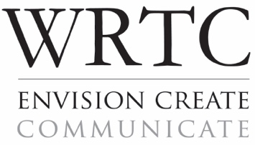
WRTC internship Agreement Form
Internship coordinator: Dr. Jen Almjeld
Email: almjeljm@jmu.edu

Student Information:
Name: | Click here to enter text. | ID #: | Click here to enter text.
Phone: | Click here to enter text. | Email: | Click here to enter text.
Semester of Internship: | Year: Click here to enter text.  Term: Fall ☐ Spring ☐ Summer ☐

The student agrees to
- Fulfill his or her obligation to work the agreed upon schedule in order to complete the required 150 hours.
- Perform all assigned tasks to the best of his or her abilities.
- Maintain confidentiality of the organization in which internship takes place.
- Prepare a closeout report that narrates and describes the internship, both in general and specific terms. The report should also evaluate the experience.

Internship Provider Information:
Name of organization: | Click here to enter text.
Address: | Click here to enter text.
Supervisor: | Click here to enter text. | Title: | Click here to enter text.
Supervisor’s phone: | Click here to enter text. | Email: | Click here to enter text.
Anticipated start date: | Click here to enter text. | Anticipated end date: | Click here to enter text.
Anticipated number of hours intern will work per week: |  |  | Click here to enter text.

The internship provider agrees to
- Provide the intern with practical work experience in some aspect of writing, rhetoric and/or technical communication.
- Provide the student with policies and operational procedures to which the student is expected to follow during the course of the internship.
- Discuss with the intern and the internship coordinator any poor work performance or difficulties that may arise before terminating an internship.
- Complete an evaluation of the intern’s performance near the end of the internship.

