Kinetic Sculpture

Beth Sweet
sweetcb@dukes.jmu.edu
3/17/20

Lesson Theme: Movement in Art

Grade level: 8th Grade

Time: 3 classes (90 minutes each)

Lesson Overview: The students will design and construct their own kinetic sculpture which is able to move via wind power. The sculpture can be free standing or hanging, and can be assembled using a variety of materials and found objects.

Challenge:
Based on what you have seen of Michio Ihara’s work, think about how you might design your own moving sculpture. Imagine how the wind will affect your sculpture’s parts, focusing on creating something that moves in a unique way. You can use any of the available materials to create a freestanding or hanging kinetic sculpture.

Visual Culture Component: Students are familiar with windmills, mobiles, and pinwheels that they have seen in their daily life. They should have an understanding that wind can be used to generate power. Now they have the opportunity to use the wind as a means of creating a moving work of art.

Virginia Standards of Learning:
- Art 8.1 The student will plan for and reflect on the art-making process, using a sketchbook/journal.
- Art 8.11 The student will create three-dimensional works of art by combining a variety of techniques and processes.
- Art 8.18 The student will critique personal work and the work of others.
Non-art SOL: Physical Science
- PS.5 The student will investigate and understand that energy is conserved. Key ideas include a) energy can be stored in different ways; b) energy is transferred and transformed; and c) energy can be transformed to meet societal needs.

Lesson Objectives:
The student will…
- Design a kinetic sculpture using 2-D media in a sketchbook. (Art 8.1)
- Construct a 3-D kinetic sculpture that is able to move using breath or wind power. (Art 8.11)
- Critique one another’s sculptures in small groups. (Art 8.18)
- Apply what they know about energy transference and transformation to design a sculpture that will convert wind power into movement. (PS.5)

Vocabulary Words for Visual Analysis:
- Kinetic sculpture- a 3-D piece of art that is able to move, creating a unique effect
- Form- a 3-D shape, with length, width, and height
- Energy- the ability of matter to do work
- Transfer- energy passing from one object to another (ex: from wind to sculpture, with movement being kinetic energy)

Historical/Cultural/Artist Information:
Artist: Michio Ihara
- Born in Paris
- BFA, Tokyo University of Fine Arts
- US Citizenship 2001
- Currently resides in Concord, Mass
- Works in large-scale, metal
- Wall, suspended, and free-standing kinetic sculpture installations

Image Descriptions:

Examples of Michio Ihara’s kinetic wind sculptures:

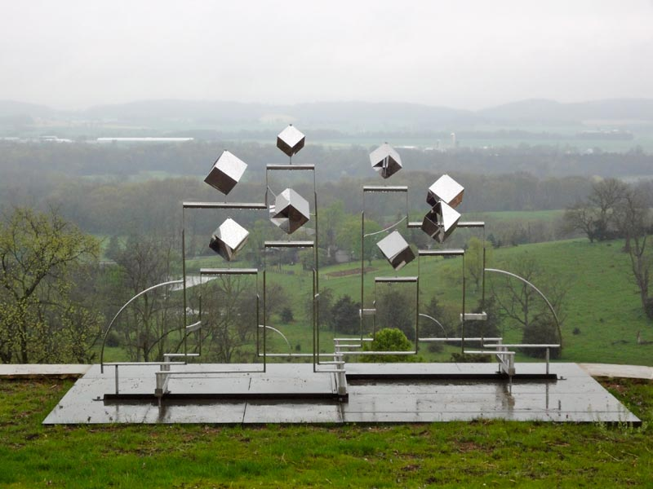
Albright Miller Residences
Harrisonburg, VA
2010

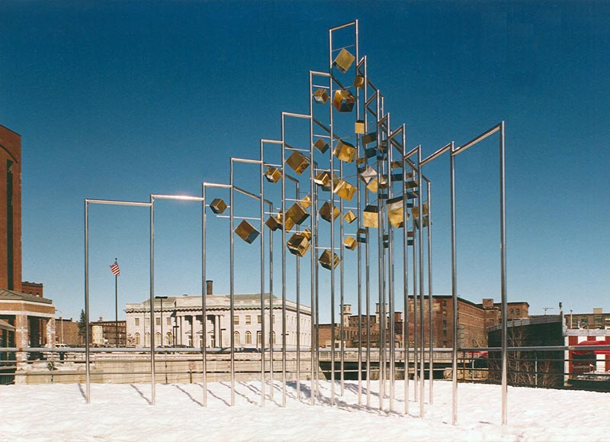
Pawtucket Prism
Lowell, MA
1986

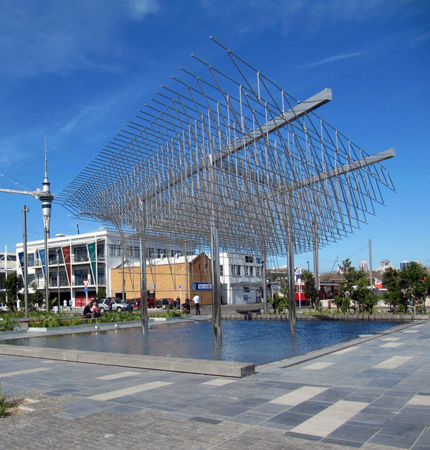
Wind Tree, Jellicoe Plaza
Auckland, New Zealand
2011
Video: https://www.youtube.com/watch?v=pWdCWAyfXEM

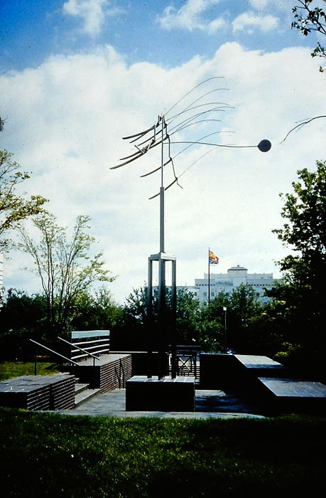
Tallahassee City Hall Park
Tallahassee, FL
1989
Video: https://www.flickr.com/photos/readerwalker/3312718280/

Lesson Procedure:
Day One: Planning
- (10 min) The teacher will introduce the lesson by showing students images and videos of Michio Ihara’s work. The teacher will explain that the project will be to design and build kinetic sculptures using a variety of materials provided. A list of the materials at hand will be provided as part of the presentation, to aid them in their brainstorming process.
- (70 min) This time is used for students to brainstorm in their sketchbooks. They should come up with at least three different designs for their final project. They should also make a list of the materials they will need for their sculpture. During this time, students who have already completed their sketches and settled on a design may begin collecting their materials to store in an assigned spot, marked with tape. (Or their cubby/shelf, if the classroom has them.) During this time, the teacher will walk around ensuring that everyone is working, and giving feedback and suggestions to students. By the end of class, the teacher should mark that each student has completed their three sketches.
- (10 min) Students will clean up their supplies, putting all materials back where they belong.

Day Two: Construction
- (5 min) The teacher will remind students what the project is, and explain material safety. The hot glue guns should remain on the counter at their specific station, on top of cardboard mats to catch glue drippings. Students can only use them there and must unplug them between uses. The X-Acto knives are to be carried with the lids on, while walking and not running. They can only be used on cutting mats, and the kids must be replaced when they are not in use.
- (75 min) This time is for construction. Students can access materials from storage bins at the counter area. They can bring what they need to their seats, and should keep clutter to a minimum to maximize their work space. Those who are working on hanging sculptures can hang them from command hooks stuck to the edge of a cabinet or table. Students should be mindful that they don’t disturb other students’ work. The teacher can continue to walk around to offer help in the form of suggestions and feedback.
- (10 min) Students should clean up, put materials in their bins, and place their work in their assigned areas.

Day Three: Critique
- (5 min) Students should set up their sculptures throughout the room.
- (10 min) The teacher will explain the following procedure, then students will do it: Each student will receive three post-it notes. They are to go around the room, looking at each work, leaving comments on post-it notes which they will stick near three of the sculptures. These notes should have good feedback or comments. (This means that each comment needs justification and can’t be a simple “I like/don’t like it.” There must be a “because…” )The teacher will monitor and suggest that more notes be put on sculptures that appear to have relatively few. The teacher can give out more post-its for students to put on these.
- (70 min) Once all the post-it notes have been distributed, each student will take a turn talking about their piece briefly, and reading and responding to one of their post-it notes.
- (5 min) Students should put their sculptures back in their spots as clean up. They may keep their comment notes and put them in their sketchbooks, or throw them away.

Evaluation:

 | 4 | 3 | 2 | 1
Planning | 3 or more designs completed, exceptionally clear and detailed | 3 designs completed, mostly clear and somewhat detailed | 3 designs completed, clarity and detail needs work | Fewer than 3 designs completed, clarity and detail needs work
Construction | Excellent craftsmanship, moves with wind or breath in a unique and interesting way, interesting forms and composition | Good craftsmanship, moves with wind or breath, good form and composition | Okay craftsmanship, some issues, moves somewhat with wind or breath, okay form and composition | Craftsmanship needs work, doesn’t move much or at all so wind or breath, forms and composition need work
Critique | 3 or more comments given, talks about own sculpture and explains it exceptionally well, responds to comment very well and with detail | 3 comments given, talks about own sculpture and explains it well, responds to comment well | 3 comments given, needs work on explanation of sculpture and comment response | Fewer than 3 comments given, needs work on explanation of sculpture and comment response

Materials and Preparation:

Day One:
- Sketchbooks
- Pencils

Day Two:
- Bins
- Paper (printer, cardstock, construction, etc)
- Cardboard
- Aluminum foil
- Wooden dowels
- Popsicle sticks
- Pipe cleaners
- Feathers
- Wire
- Twine
- Foam blocks
- Command hooks
- Craft glue
- Hot glue guns and sticks
- Staples
- Tape
- Scissors
- X-acto knives
- Cutting mats

Day Three:
- Finished sculptures
- Post-it notes
- Pencils

Resources:

http://www.michioihara.com/sculpture/details/2010_Albright_Miller_Residences_VA.html

http://www.likelowell.com/public-art-walk/2017/7/7/pawtucket-prism

http://www.michioihara.com

https://m.huffpost.com/us/entry/us_58a9ba22e4b0b0e1e0e20c58

https://www.rockefellercenter.com/blog/2018/07/17/q-michio-ihara/

https://www.scholastic.com/teachers/articles/teaching-content/tips-teaching-gifted-students/

Special populations:
Gifted and Talented
- Allow students to give input on lessons
- Allow students to pursue their interests within assignments
- Provide resources for students to do more exploration if they have completed early
- Ask for advice from parents regarding specific students and their learning style and needs
- Give extra challenges to those who want them, by adding criteria or suggestions for the project at hand (Ex: for this assignment, students could be challenged to make their sculptures using only one type of material, or only found objects)

