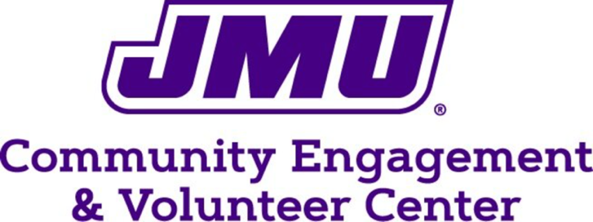

Service Hours Log
Name: ___________________________ JAC #: ________________________________
Email: _____________________@dukes.jmu.edu Cell: ________________________________
Check one:
Semester: Fall Spring Year: 20________
Reason for Service Placement: Course/Major Requirement CSP Requirement Self-Interest
For Course or Major Requirement:
Course: ______________________ Instructor: _______________________
Community Partner: _____________________________________________
Community Partner Representative: _________________________________________
Date | Time In | Time Out | Hours | Responsibility (What did you do?)
Total Hours:
Service-Learner Signature: ______________________________________ Date: ____________________
Agency Representative Signature: ________________________________ Date: ____________________
If your service-learning is for a class, please turn this form in to your professor so that you can receive credit for your work.

