~ FA ’24 JMU VOCAL AREA INFORMATION SHEET ~

JMU CHOIRS FA 2024 AUDITIONS

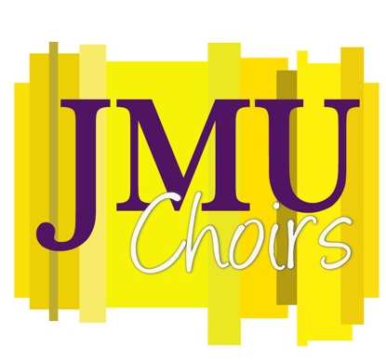

~ FA ’24 Auditions for

The Madison Singers …. The JMU Chorale …..Treble Chamber Choir and assignments to the University Men’s and Women’s Choruses

will be held on:

Tuesday, August 20, 2024: 4:00 pm - 9:00 pm

Wednesday, August 21, 2024: Throughout the day and evening, as indicated on audition schedule.

Thursday, August 22, 2024: Morning only, as indicated on audition schedule.

All JMU UNDERGRADUATE VOCAL AREA PERSONNEL
who are registered for voice lessons in the FA ’24 semester are required to audition, regardless of prior or projected ensemble participation
(including opera roles and castings).

Please sign up for your audition via our on-line scheduling software:
https://jmu.jury-system.com

As most of you already know, user accounts are created automatically by clicking the Login link in the main menu and logging in through the JMU portal and Duo two-factor authentication system. Enter your usual JMU credentials.

- Once logged in, proceed to the Booking Tab.

- Follow the listed instructions and signup for an audition time.

- Please note the audition room listed on the sign-up form.

The signup window will be open on August 10, 2024

Remember that Wednesday, August 21, is our first full day of regularly-scheduled classes,
so please check your class schedule! Choral ensemble auditions are not excused absences from classes.

If you need to change your audition time, please follow the jury-systems instructions accordingly. You will receive a cancellation code when you register, just in case.

Audition results notifications will be sent out via our Canvas class as well as be posted on the bulletin board outside Dr. V’s office (rm.338) on or before noon on Thursday, August 22.

In order to be respectful of rehearsal time and curricular needs, rehearsals for non-auditioned ensembles will begin on Wednesday, August 23, 2024, even if auditions are not fully completed. Personnel shifts due to auditions will be credited with full attendance in their assigned ensembles.

~AUDITION PROCEDURES~

Please note that this semester there will be no required aria for choral auditions.

- Present the prepared audition material: Messiah #9; O Thou That Tellest: Rehearsal H to the end

- Prepare to sight read a short excerpt.

Instructions and Helpful Hints for Preparation

Prepared Audition Material (Messiah #9): Please learn YOUR voice part in this Messiah chorus from rehearsal H (measure 146 to the end of the movement.) Please sing on solfege or on text, as you prefer.

Listening to this piece is a must for a successful audition. This piece is deceptive, and you cannot present it stylistically correctly without first listening to it several times. An audio clip is included in the audition information for your assistance (choir begins at 4’20”).

Please note as well that there will be no accompaniment at this audition, so you must know the piece well in order to present it. Please plan to sing either in solfege or text, as you prefer.

Sight-reading: Please don’t worry about this, and do plan on bringing your tuning fork if you have one!

The Day of Your Audition
Please arrive 15-20 minutes early to your audition to allow for:
Intake paperwork, the SIGHTREADING portion of the audition, and schedule shifts.
Please plan to:

- Arrive early! (Early is on time!)

- Bring your tuning fork if you have one! You will use it during your audition!

- Dress up! LOOK YOUR BEST! An audition is always a practice for the next concert, solo, or audition! Your career is NOW; act the part and bring it!

- Fill out an information form and give it to your door monitor when completed.

- Present the required audition material, Messiah #9; O Thou That Tellest: Rehearsal H to the end following the instructions as indicated on the music excerpt itself.

- Sight-read from material provided at the audition itself.

