Science On a Sphere
Program for High School Groups: ready-to-implement lessons and a teaching tutorial

Pilot Version IV

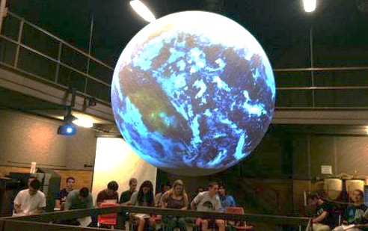
Authors: Editors:
Jennifer Mangan, Ph.D. Christie-Joy B. Hartman, Ph.D.
Kristen St. John, Ph.D.
Reviewers: Christy Bradburn
Mace Bentley, Ph.D.
Robert Brent, Ph.D.
Hilary Peddicord

Development of this material was partially supported by a grant from the Ohrstrom Foundation.

Table of Contents
Overview of the Lesson 3
Acknowledgements 4
Lesson : Climate Change 5
Supplemental Material: Teaching Demonstration Video 22

Overview of the Lesson

The purpose of the lesson in this manual is to provide teachers and facilitators with a relevant and effective resource for teaching with Science On a Sphere (SOS) and assessing students’ learning. The lesson was developed for use with high school students but could be adapted to other grade levels. The lesson is correlated to the Virginia Standards of Learning (SOLs) and the Next Generation Science Standards.

The manual includes:
Learning Objectives Presentation Tips

Correlations to Virginia SOLs Instructor Script

Correlations to Next Generation Audience Frequently Asked
Science Standards Questions (FAQs)
Dataset Descriptions Pre & Post Lesson Assessment

Student Handouts & Worksheets

The manual also includes instructions to access a supplemental video that illustrates an interactive lesson with Science On a Sphere. The video is interspersed with commentary regarding pedagogy with SOS.

The manual is in pilot form. Please email stewardship@jmu.edu if you have any feedback on the lessons presented here.

Acknowledgements

The editors thank James Barnes, Instructor, Department of Integrated Science and Technology for his work assembling and editing some parts of the manual. We also thank Mace Bentley, Professor, Geographic Science Program, School of Integrated Sciences, Robert Brent, Associate Professor, School of Integrated Sciences and Hilary Peddicord, Education Specialist, National Oceanic and Atmospheric Administration for reviewing this manual. We appreciate the grant from the Ohrstrom Foundation that partially supported this work.

Lesson: Global Climate Change
By Jennifer Mangan, Ph.D., Associate Professor, Department of Interdisciplinary Liberal Studies, James Madison University
Run time: 30 minutes

Learning Objectives

Students will be able to identify greenhouse gases. They will be able to articulate the difference between weather and climate, as well as the difference between the Greenhouse Effect and the rise in global surface temperatures over time. Students will be able to identify evidence of the factors that have caused the rise in global surface temperatures over the past century.

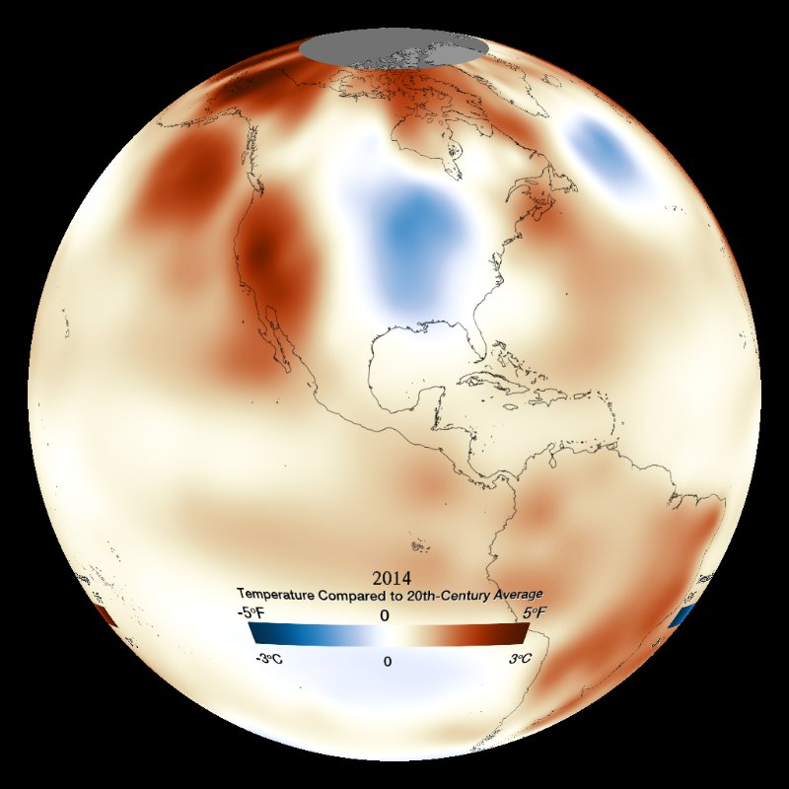
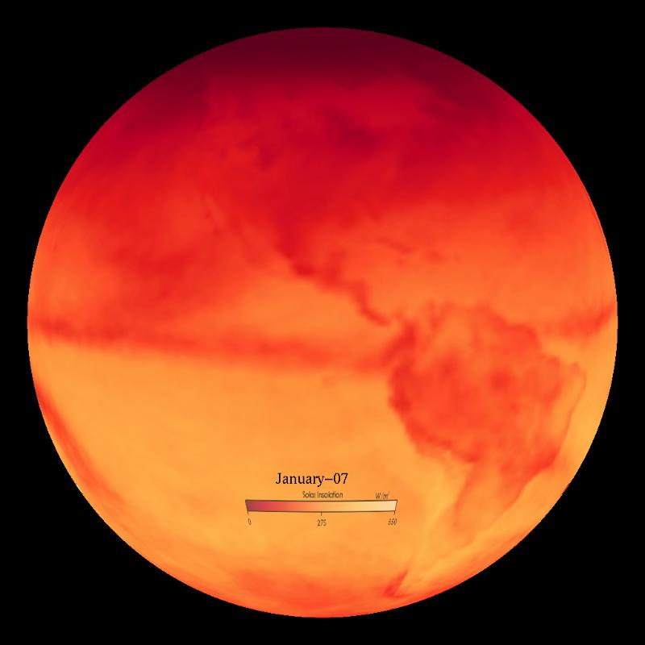

Left: Temperature Anomaly: Monthly (NASA) – 1884-2012
Right: Solar Insolation on Earth

STANDARDS OF LEARNING

6.6: The student will investigate and understand the properties of air and the structure and dynamics of Earth’s atmosphere. Key concepts include:
d) Natural and human-caused changes to the atmosphere and the importance of protecting and maintaining air quality

ES.12: The student will investigate and understand that energy transfer between the sun and
Earth and its atmosphere drive weather and climate on Earth. Key concepts include:
d) Weather phenomena and the factors that affect climate including radiation, conduction, and convection

Next Generation Science Standards

ESS3.D: Global Climate Change
  - Human activities, such as the release of greenhouse gases from burning fossil fuels, are major factors in the current rise in Earth’s mean surface temperature (global warming). Reducing the level of climate change and reducing human vulnerability to whatever climate changes do occur depend on the understanding of climate science, engineering capabilities, and other kinds of knowledge, such as understanding of human behavior and apply that knowledge wisely in decisions and activities. (MS-ESS3-5)

Datasets

Temperature Anomaly: Yearly (NOAA) – 1880-2016
This animation shows Earth's surface temperature from 1880 through 2016 compared to the 20th century average.
https://sos.noaa.gov/datasets/temperature-anomaly-yearly-noaa-1880-2016/

Solar Insolation on Earth
This visualization depicts the amount of solar radiation reaching the Earth’s surface by month (2007). http://sos.noaa.gov/Datasets/dataset.php?id=49

Carbon Flux
The data show daily average carbon flux with green indicating overall CO₂ uptake (example: photosynthesis exceeds respiration during summer months) and red indicating overall CO₂ emission (example: respiration exceeds photosynthesis in winter, or burning of fossil fuels in cities). http://sos.noaa.gov/Datasets/dataset.php?id=26

Biosphere: Marine Chlorophyll Concentration and Land Vegetation
This dataset shows quantity of marine and land-based plant-life as it changes throughout the seasons of the year. http://sos.noaa.gov/Datasets/dataset.php?id=168

Sea Ice: Fraction and Solar Radiation Absorption
Albedo is a unitless measure of the amount of solar radiation that is reflected back into space. Light colored surfaces (such as snow, ice, or deserts) have high albedo and reflect the most radiation, while dark colored surfaces (such as oceans, forests, or pavement) have low albedo.
http://sos.noaa.gov/Datasets/search.php?q=albedo

Sea Ice Extent – 1978-2018
Data depicts the growth and decay of sea ice every 10 days from 1978-2018. Maximum annual extent is typically seen in March for the Arctic, and minimum annual extent is typically seen in September for the Arctic, with opposite patterns for the Antarctic. http://sos.noaa.gov/Datasets/dataset.php?id=187

Sea Ice Extent: September Only – 1979-2017
Similar to the previous, this dataset depicts only the annual minimum extent of Arctic sea ice from September for each year (1979-2017) and provides a more clear view of the continued reduction in sea ice in the Arctic. http://sos.noaa.gov/Datasets/dataset.php?id=188

Global Climate Change Worksheet (Page 1 of 2)
1. What is the difference between weather and climate?

2. What are some reasons to be concerned about climate change on Earth?

3. Why is it important to study temperature over long periods of time?

4. What is an anomaly? Why are anomalies important in the study of climate change?

5. Why do we measure the amount of sea ice on Earth?

Global Climate Change Worksheet (Page 2 of 2)

6. In North America, what will happen to the East Coast as sea level rises? Would you expect the same effect on the West Coast? Why or why not?

7. What evidence indicates that climate-warming trends over the past century are primarily due to human activity?

8. What are some potent greenhouse gases? How do greenhouse gases affect a planet’s habitability, including Earth’s?

9. Do you expect cities or rural areas to emit more CO₂ into the atmosphere? Why?

10. Is the Greenhouse Effect the same thing as global warming? Why or why not?

Global Climate Change Worksheet Answer Key (Page 1 of 2)
1. What is the difference between weather and climate?
- Weather refers to short-term atmospheric conditions (sunshine, rainy, cloudy, windy, etc.). Climate is weather for an extended period of time (average temperature, average precipitation, etc.).

2. What are some reasons to be concerned about climate change on Earth?
- Sea level rise
- Melting sea ice
- More storms and potentially more powerful storms due to warmer water
- Animal extinction and loss of habitat
- Desertification
- Loss of cropland/places to grow food
- Changing precipitation patterns
- Ocean acidification
- Displacement of populations in coastal areas
- Others
3. Why is it important to study temperature over long periods of time?
- Studying long-term temperature averages allows us to identify past climate patterns and predict future climate conditions. It also helps us understand human influences on climate. Global average temperature is one of the most-cited indicators of global climate change (source: https://www.ncdc.noaa.gov/indicators/).
4. What is an anomaly? Why are anomalies important in the study of climate change?
- An anomaly is a deviation from normal. So, it is when something is different from what we normally see or expect.
- Anomalies are important when we look at climate change because we want to see where things are changing, especially temperatures and greenhouse gases.

5. Why do we measure the amount of sea ice on Earth?
- Sea ice has a fast response time to heating, therefore it is like a “canary in the coal mine” – the changes in sea ice in the Arctic are an early signal that rising temperatures are impacting the environment. [Note that changes in sea ice around Antarctica are very different than the Arctic; one of the reasons for this is because the large, thick, and cold Antarctic ice sheets keep the surrounding waters cooler and easier to maintain the sea ice.]
- Sea level rise is caused by (1) the influx of melted land ice (especially glaciers that have a shorter response time than larger thicker ice sheets) and (2) the thermal expansion of sea water. Note this common misconception: Melting of sea ice does NOT cause any significant change in sea level to rise. Sea ice is already displacing sea water so when it melts (or forms) it has no important net effect on the rise (or fall) of sea level. See: http://oceanservice.noaa.gov/facts/sealevel.html.

6. In North America, what will happen to the East Coast as sea level rises? Would you expect the same effect on the West Coast? Why or why not?
- The impact of sea level rise depends on the shape and topography of the coastline. In general, the eastern coastline is flatter and more gently sloped, while the western coastline is steeper. This means that the same increase in sea level will inundate (or cover) more coastline area along the east coast. In addition to the difference in coastline topography, model predictions indicate that the east coast will also see higher regional sea level rise due to weakening of ocean circulation patterns in the Atlantic Ocean. This weakening is expected to cause the Atlantic to warm more quickly and sea level to rise more quickly due to thermal expansion.
7. What evidence indicates that climate-warming trends over the past century are primarily due to human activity?
- Carbon dioxide levels in the atmosphere started increasing around 1850, just about the time people started burning fossil fuels for energy. (source: http://climate.nasa.gov/causes/)
- Human activities, such as the burning of fossil fuels (e.g., coal, oil, and gas) and clearing of forests, have increased the concentration of carbon dioxide, one of the greenhouse gases that traps heat, in the atmosphere by more than 40% since the Industrial Revolution. (source: https://www.climate.gov/)
- Ice cores drawn from Greenland, Antarctica, and tropical mountain glaciers show that the Earth’s climate responds to changes in greenhouse gas levels. Ancient evidence can also be found in tree rings, ocean sediments, coral reefs, and layers of sedimentary rocks. This ancient, or paleoclimate, evidence reveals that current warming is occurring roughly ten times faster than the average rate of ice-age-recovery warming. (https://climate.nasa.gov/evidence/)
8. What are some potent greenhouse gases? How do greenhouse gases affect a planet’s habitability, including Earth’s?
- Water vapor, carbon dioxide, methane, and nitrous oxide are all greenhouse gases in the Earth’s atmosphere.
- Without the greenhouse effect, the Earth would be too cold to sustain life. The planet would be much colder (~33 degrees C colder on average).

9. Do you expect cities or rural areas to emit more CO₂ into the atmosphere? Why?
- Cities. More greenhouse gases are produced in cities because of the concentration of people, cars and industries.

Global Climate Change Worksheet Answer Key (Page 2 of 2)

10. Is the Greenhouse Effect the same thing as global warming? Why or why not?
- No. This is an important misconception. The Greenhouse Effect has always existed and it is what is responsible for keeping Earth habitable. “Global warming” is a recent enhancement of the greenhouse effect due to increased carbon dioxide in the atmosphere from the burning of fossil fuels.

Presentation Tips
- Orient your audience to the Sphere with the Blue Marble dataset, if you have not done so in the previous lesson. You might also use this time to talk briefly about what the Sphere is and how it was developed, but remember your audience is likely to be uninterested in the technical specifics if they are elementary to middle school age.
- Lengthen the program by having students look at the scale bars on a few of the datasets. Lead a discussion as to why we have scale bars and why these are important in scientific datasets such as SOS.
- Distribute the worksheet developed for this script at your discretion as time allows. It can be used in a number of ways:
  - Distribute it before the Sphere presentation and have students work individually or in small groups to see if they know the answers. Then do the Sphere presentation and have them write the correct answers as they encounter them during the show.
  - Hand out the worksheet just before the presentation and have students look and listen for the answers. Discuss afterwards.
  - Use the worksheet as an assessment of the presentation. Distribute it for individual work after the presentation has been completed.

Research Sources
The information in this outline represents the bare essentials for facilitating the lesson. It is expected that facilitators spend time doing some research to add accurate detail. Since this program is meant to be very interactive, preparation for student questions is essential. Each of the datasets has a page on the NOAA Science On a Sphere website. Here are some other useful links.
- NOAA Climate Change Information
https://www.climate.gov/
- EPA Climate Change Information
http://www.epa.gov/climatechange/ (click on this one : / )
- Intergovernmental Panel on Climate Change (IPCC)
http://www.ipcc.ch/
- NASA Climate Change Information
http://climate.nasa.gov/

Instructor Script

Temperature Anomaly: Yearly (NOAA) – 1880-2016
Have students observe the visualization and familiarize themselves with the placement of oceans and continents. Have them look at the different colors shown.

What is an anomaly?
  - It is a deviation from normal.

What is “normal” temperature?
  - For this data set, “normal” is the 20th Century global average temperature.

What do the different colors on the sphere mean?
- Red is indicative of higher average yearly temperatures compared to the 20th Century average.
- Blue is indicative of lower average yearly temperatures compared to the 20th Century average.

What happens to the colors over time, and what does that mean?
  - The Earth becomes more red, meaning that the average temperature has increased.

Where do you notice the greatest warming occurring?
  - The greatest warming is taking place in the Arctic.

What evidence do we have that climate-warming trends over the past century are due to human activity?
- Carbon dioxide levels in the atmosphere started increasing around 1850, just about the time people started burning fossil fuels for energy. (source: http://climate.nasa.gov/causes/)
- Human activities, such as the burning of fossil fuels (e.g., coal, oil, and gas) and clearing of forests, have increased the concentration of carbon dioxide, one of the greenhouse gases that traps heat, in the atmosphere by more than 40% since the Industrial Revolution. (source: https://www.climate.gov/)
- Ice cores drawn from Greenland, Antarctica, and tropical mountain glaciers show that the Earth’s climate responds to changes in greenhouse gas levels. Ancient evidence can also be found in tree rings, ocean sediments, coral reefs, and layers of sedimentary rocks. This ancient, or paleoclimate, evidence reveals that current warming is occurring roughly ten times faster than the average rate of ice-age-recovery warming. (https://climate.nasa.gov/evidence/)
Increasing global temperature is only one element of observed global climate change. Precipitation patterns are also changing; storms and other extremes are changing as well. (source: https://www.ncdc.noaa.gov/indicators/ )
Global warming refers only to the Earth’s rising surface temperature, while climate change includes warming and the “side effects” of warming—like increases in extreme weather, heavier rainstorms, or more frequent drought. Global warming is one symptom of the much larger problem of human-caused climate change. (source: https://www.climate.gov/news-features/climate-qa/whats-difference-between-global-warming-and-climate-change)
Solar Insolation on Earth
What is solar insolation?
  - Literally, it is incoming solar radiation

Has insolation been changing?
  - No, it is fairly constant.

The amount of radiation reaching the Earth varies with the seasons, but over time there is more and more radiation reaching the Earth. Sunspot cycle trends are now clearly shown to not be a primary influence on the climate warming trend we see (see: https://www.climate.gov/news-features/understanding-climate/climate-change-incoming-sunlight) so something else has to be holding the warmth in. We are absorbing more energy, but the amount of energy arriving is not changing.

Carbon Flux
These data show carbon dioxide in the atmosphere. Red indicates CO₂ emission and green indicates CO₂ absorption. Have students observe the spatial patterns of carbon flux around the globe as well as the seasonal patterns in carbon flux.

Where is there the most red?
  - Near cities and densely populated areas.

Why is red concentrated near cities?
  - CO₂ released from the burning of fossil fuels.

What natural process consumes CO₂?
  - Photosynthesis

Seasonally, when is CO₂ uptake the greatest?
  - Summer months (winter and summer are opposite in the northern and southern hemispheres).

Plants take in CO₂ for photosynthesis. So when the plants are dormant or dead in the northern hemisphere winter, they release CO₂, which adds it to the atmosphere. The opposite is true during the northern hemisphere summer, plants absorb CO₂, which decreases it in the atmosphere. Because Earth has more land mass in the northern hemisphere, and hence more plants, the seasons of the northern hemisphere drive annual patterns of global CO₂ – higher in the northern hemisphere winter, and lower in the northern hemisphere summer.
Why is there a lot of red in the South American rainforests during parts of the year?
  - Logging and burning of rainforests lead to increased CO₂ emissions.

Increasing carbon dioxide levels lead to a positive feedback loop with water vapor, causing even greater warming. As the atmosphere is heated from CO₂ emissions, the amount of water vapor in the atmosphere will also increase because as the air temperature gets warmer the rate of evaporation increases. More water vapor in the atmosphere increases the greenhouse effect, warming the atmosphere and again increasing the amount of water vapor in the atmosphere.

Why if the CO₂ emissions are greatest in the cities, is the greatest warming is observed in the Arctic (far from most cities)?
- Shiny ice and snow easily reflect the sun's energy back into space. As the Arctic loses snow and ice, bare rock and water absorb more and more of the sun’s energy, making it ever warmer. This is called the albedo effect, which is what causes places like the Arctic to warm faster.
- You can imagine how this could be a perpetuating cycle. We call this a positive feedback loop, the more ice melts, the more the underlying surface heats up, the more ice melts…

Biosphere: Marine Chlorophyll Concentration and Land Vegetation
This animation shows us the amount of vegetation covering the land, and the amount of photosynthetic life in the surface water and how it changes throughout the year.
Note: The photosynthetic life in the surface waters are not in the Plant Kingdom. They are mostly algae (Protista Kingdom).

What parts of the globe do you see have the most vegetation?
  - Rainforest/South America
  - Boreal Forest/Northern Asia and Canada

Where do you notice little to no vegetation?
- Sahara Desert/North Africa

Rainforests in South America are being cleared for agriculture, contributing to warming in more than one way. Deforestation directly releases CO₂ into the atmosphere, often through burning vegetation. It is also important to remember that plants consume CO₂ during photosynthesis.

Sea Ice: Fraction and Solar Radiation Absorption
Albedo is a unitless measure of reflectivity, typically reported as a number between 0-1. A high albedo means a more reflective surface, therefore less absorption of heat energy by the surface.

If 0 is low and 1 is high, what would you say for example the albedo is of blacktop pavement?
- Zero. If you’ve ever noticed how hot the blacktop pavement gets on a summer day, this is because the black surface has very low albedo (low reflectivity) and absorbs most of the heat energy that it receives from the Sun. Compare this to a light-colored concrete sidewalk, with a relatively high albedo, it reflects much of the heat energy from the Sun.

Where do you see dark colors on the globe?
  - Up at high latitudes, but not quite at the poles.

If light colors have high albedo and high reflection, how much heat do you think snow would absorb?
  - Not much, most of the heat is reflected.

If the snow was covered in a layer of black soot from the burning of fossil fuels, what effect might that have on the snow?
  - Darker in color, lower in albedo, higher heat absorption, increased melting.

You saw earlier that the greater temperature anomaly was in the Arctic. How would the increased temperatures there affect ice cover and therefore albedo?
  - Increased temperatures would cause melting of the ice. Less ice means decreased albedo.

How does this create a [harmful] feedback loop?
  - Increased temperatures would cause melting of the ice. Less ice means decreased albedo. Decreased albedo leads to greater warming. Greater warming leads to more melting of ice. Therefore, the loop continues.

Sea Ice Extent – 1978-2018
Data depicts the growth and decay of sea ice year-round (every 10 days) from 1978-2018.

Can you see an annual pattern in the amount of sea ice present?
  - Yes, in the Arctic the maximum extent is around March (end of winter), and the minimum extent is seen around September (end of summer). It is the opposite in Antarctica.

Why are the Arctic and Antarctic annual (seasonal) patterns opposite?
  - Because of the opposite seasons, melting takes places in the summers.

Can you see a general trend in the amount of sea ice from 1978-2018 in the Arctic?
  - Yes, there is an overall decrease in the amount of sea ice over time.
Note: We see a decrease in amount of sea ice over time only in the Arctic – not in the Antarctic. Changes in sea ice around Antarctica are very different that the Arctic; one of the reasons for this is because the large, thick, and cold Antarctic ice sheets keep the surrounding waters cooler and easier to maintain the sea ice.

Sea Ice Extent: September Only – 1979-2017
This is similar to the previous dataset, only showing sea ice extent around the annual minimum at the end of the melting season. The overall loss of sea ice over time is more easily observed in the absence of the annual fluctuation.

How can this be related to the albedo concept we just discussed?
  - Light/white colored snow is being replaced with dark/black colored oceans. This is another positive feedback loop, where less ice = more warming = less ice, etc.

According to NASA, quote “Multiple studies published in peer-reviewed scientific journals show that 97 percent or more of actively publishing climate scientists agree: Climate-warming trends over the past century are extremely likely due to human activities.” (source: http://climate.nasa.gov/scientific-consensus/)

We have not yet exactly quantified the magnitude of human impacts. Some of the negative effects of global climate change include melting of sea ice, sea level rising, warmer ocean water can cause more storms, and changing animal habitats can contribute to extinction, desertification, and reduction in cropland/farmland.

Conclude this lesson by having students brainstorm in small groups ways they can reduce their carbon emissions. Solicit examples from the groups when they are done.

Audience FAQs
1. Are we unsure if humans are causing climate warming?
- This is often misinterpreted and misrepresented. According to NASA, quote “Multiple studies published in peer-reviewed scientific journals show that 97 percent or more of actively publishing climate scientists agree: Climate-warming trends over the past century are extremely likely due to human activities.”(source: http://climate.nasa.gov/scientific-consensus/)

2. Are the Greenhouse Effect and global climate change the same thing?
  - No. The Greenhouse Effect is a naturally occurring phenomenon that makes Earth habitable. Without natural greenhouse gases, Earth would be too cold to host life. An enhanced greenhouse effect is the concern, i.e., human activity will put too many excess greenhouse gases into the atmosphere and these will trap heat causing the Earth’s climate to warm.

3. Is the ozone hole responsible for global climate change?
  - No. The ozone hole is a different atmospheric phenomenon. While the hole in the ozone and global climate change are both caused by pollutants in the atmosphere, they are not the same thing and do not influence one another. The ozone hole is created when chlorofluorocarbons, or CFCs, react with ozone to turn it into ordinary oxygen, which does not have the same capacity as ozone to block UV rays from the Sun. Global climate change is when excess greenhouse gases in the atmosphere trap more outgoing radiation from the Earth, keeping Earth warmer.

4. Is climate change just a natural phenomenon that goes in cycles? Have we seen climate change throughout all of Earth’s history?
  - It is true that Earth’s climate has been in flux for all of its history. There are natural variations in climate and short-term fluctuations are natural and expected. However, there is an upward trend in global surface temperature over approximately the last half century.

5. If we stopped burning fossil fuels today, would it stop global climate change?
  - The effect of greenhouse gases in the atmosphere would persist for many decades, even if we were to stop burning of fossil fuels today. If we immediately stopped atmospheric pollution, scientists predict some recovery in 50 to 100 years, but some damage has already been done.

6. How do we know the Earth's climate is warming?
  - “Thousands of land and ocean temperature measurements are recorded each day around the globe. This includes measurements from climate reference stations, weather stations, ships, buoys and autonomous gliders in the oceans. These surface measurements are also supplemented with satellite measurements. These measurements are processed, examined for random and systematic errors, and then finally combined to produce a time series of global average temperature change. A number of agencies around the world have produced datasets of global-scale changes in surface temperature using different techniques to process the data and remove measurement errors that could lead to false interpretations of temperature trends. The warming trend that is apparent in all of the independent methods of calculating global temperature change is also confirmed by other independent observations, such as the melting of mountain glaciers on every continent, reductions in the extent of snow cover, earlier blooming of plants in spring, a shorter ice season on lakes and rivers, ocean heat content, reduced arctic sea ice, and rising sea levels.“ (source: https://www.ncdc.noaa.gov/indicators/)

Pre & Post Assessment
The following assessment can be given to measure student knowledge before and after the lesson.

1. What is an anomaly?
- It is the key to finding something on a map.
- It is when something is different from what we think is normal.
- It is the burning of fossil fuels.
- It is when things change with the seasons on Earth.

2. What is something that can happen when Earth gets warmer?
- Sea level can rise.
- Animals can go extinct.
- Melting ice at the poles.
- Less land for growing food crops.
- All of the above can happen.

3. Why do scientists look at reflectivity (albedo) of Earth’s surface?
- Surfaces that reflect a lot of the Sun’s energy stay cooler.
- They are worried about sunburn.
- It changes the amount of energy given off by the Sun.
- It kills crops.

4. True or False: Many publishing climate scientists agree: Climate-warming trends over the past century are extremely likely due to human activities.
- True
- False

Supplemental Material: Teaching Demonstration Video

By Kristen St. John, Ph.D., Professor, Department of Geology and Environmental Science, James Madison University

Duration: 57 minutes

This video provides an example of pedagogical practices with SOS. This video is a recording of an actual interactive climate model lesson by Professor Kristen St. John with her upper division college science students. The video is interspersed with commentary regarding pedagogical practices that are applicable to SOS lessons at the middle and high school level as well as at the collegiate level. The video contains three parts:

Part 1: Part I: Framing the discussion in the classroom prior to using SOS (20 min)

Part 2: Utilizing the SOS climate model datasets (28 min)
a) Providing handouts with guided questions
Dataset Discussion: GFDL A1B Model - Temperature Change with Business as Usual

b) Orienting students to visualizations
Dataset Discussion: HAD A1B Model - Temperature Change with Business as Usual
Dataset Discussion: GFDL B1 Model - Temperature Change with a More Ecologically Friendly Scenario
Dataset Discussion: GFDL 3714 Model - Sea Ice Change

c) Viewing visualizations multiple times
Dataset Discussion: GFDL Model - Precipitation Anomalies

Part 3: Using the flat screen: summary and assessment (9 min)
a) Summarizing the take away message on flat screen
b) Following up with an assessment

Please e-mail stewardship@jmu.edu, and you will receive a link to the video and an access code.

All icons used in this manual are Creative Commons images and selected from the Noun Project https://thenounproject.com. Individual designer attribution for each icon is below: Learning Objectives: Pete Fecteau, VA SOL Correlations: Jan Christoph Borchardt, Next Generation Science Standards: Adrian Rguez Perez, Dataset Descriptions: Creative Stall, Student Handouts and Worksheets: Jaclyn Ooi, Presentation Tips: mh, Instructor Script: TukTuk Design, Audience FAQs: Anas Ramadan, and Pre & Post Visit Assessment: Berkay Sargin.
NASA / Goddard Institute for Space Studies (GISS)
The Globe Program NASA Earth Observations (NEO)

