Adobe Sign Instructions:

1. Sign in or request access here: <https://www.jmu.edu/computing/administrative-and-business/electronic-signature.shtml>.
2. Select Request e-signatures.

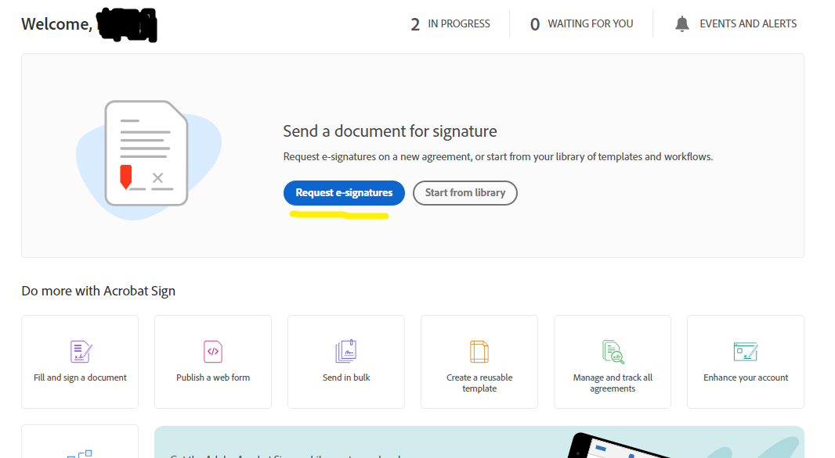

1. Enter your email and the email of anyone else who will need to sign the document.

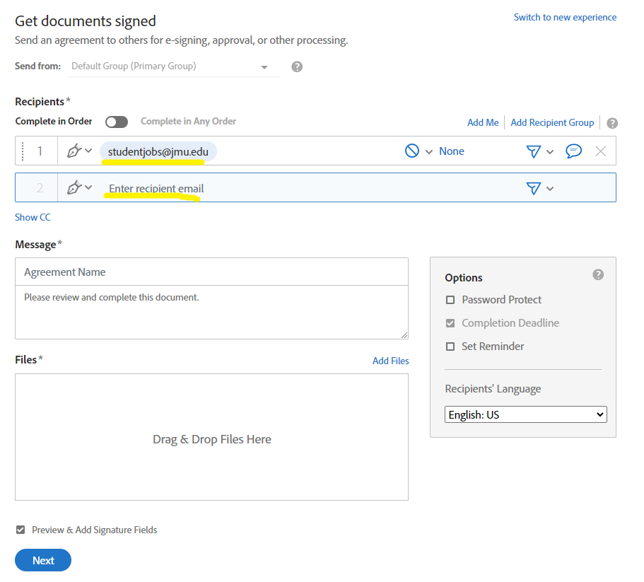

1. Add the name of the form. Add any instructions or other information in the message.

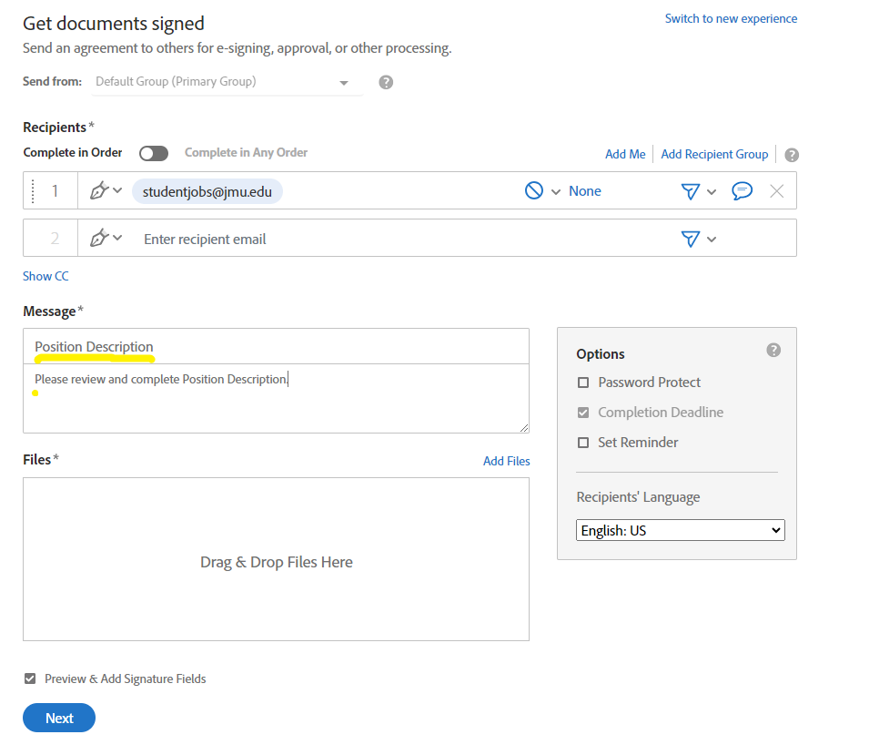

1. Attach the document. Select Next.

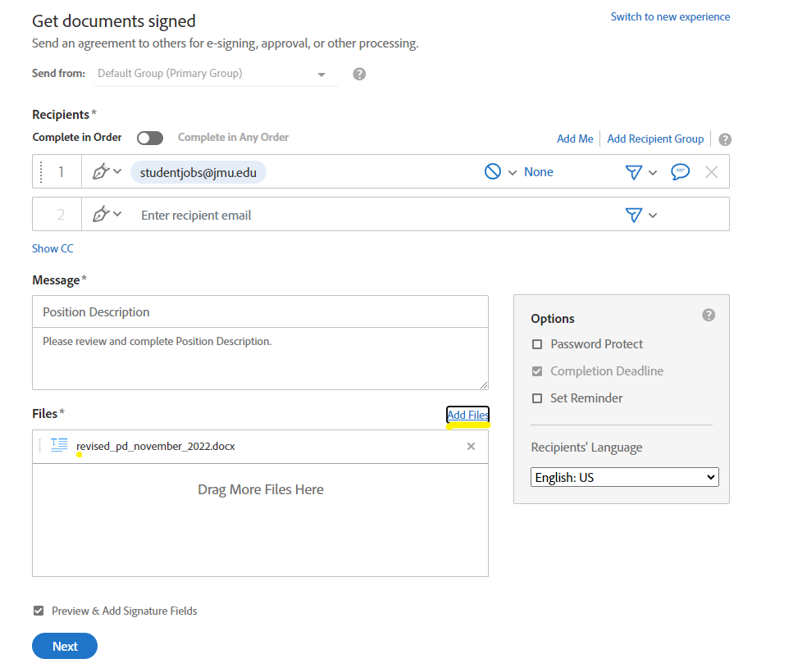

1. Drag and Drop the Signature Field to where the signature is needed. (if two signatures are needed, be sure to add two Signature Fields) Select Send.

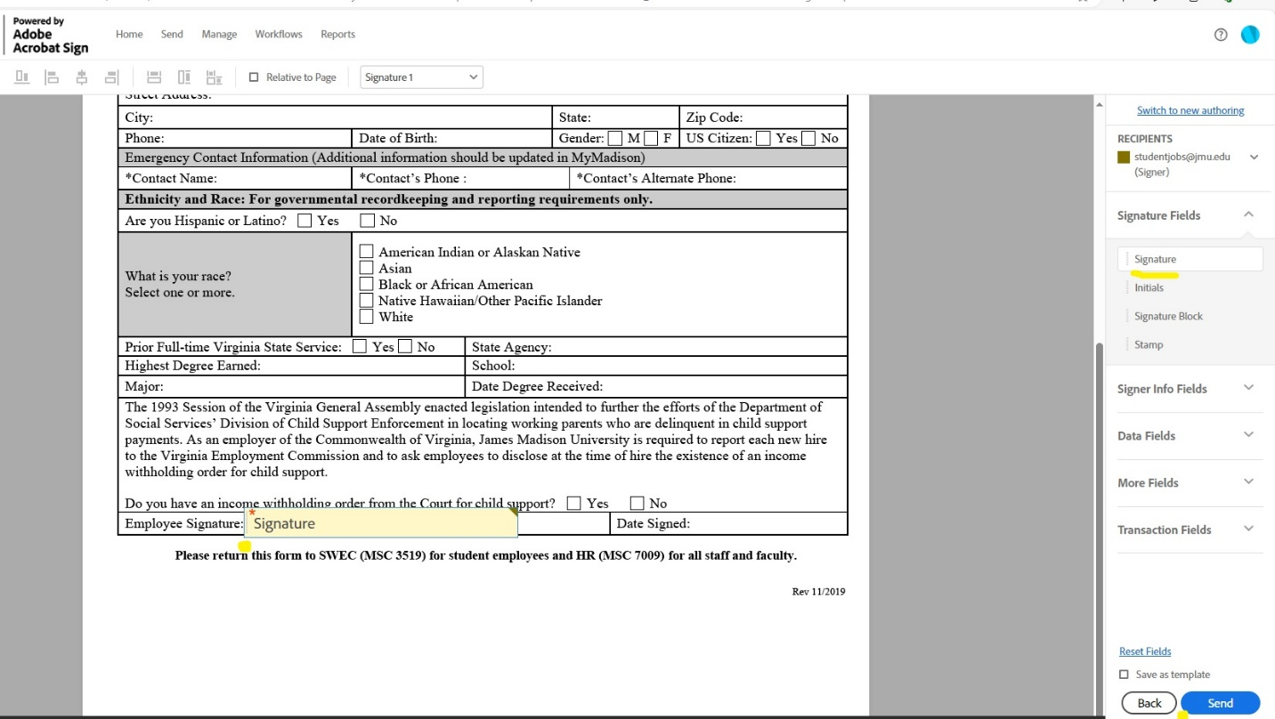

1. Open email. Select Review and sign.

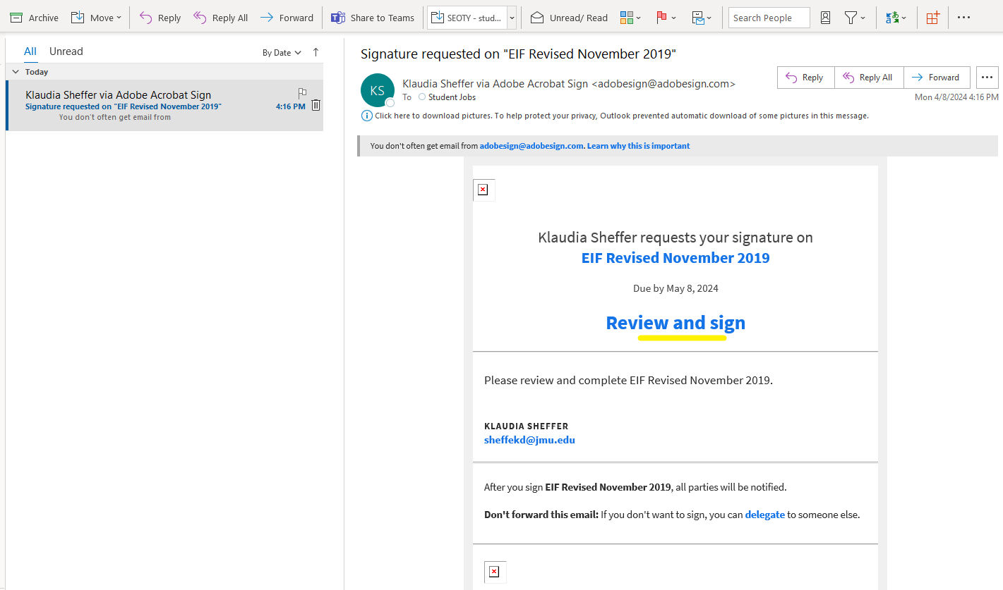

1. Select the “Click here to sign” signature box. Type your signature in the pop-up. Select Apply. Select Click to Sign in the black pop-up box along the bottom.

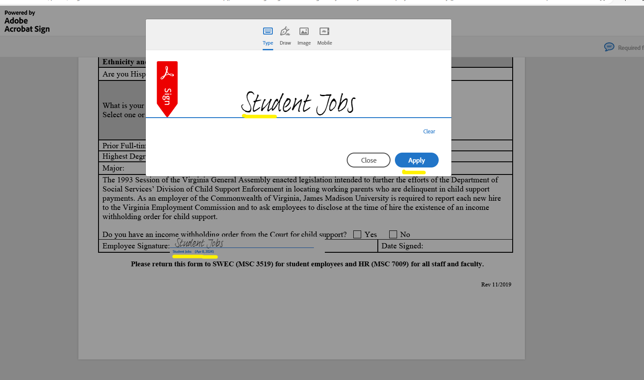

1. You can then download a copy. Or go back to your Adobe account and save/download there.

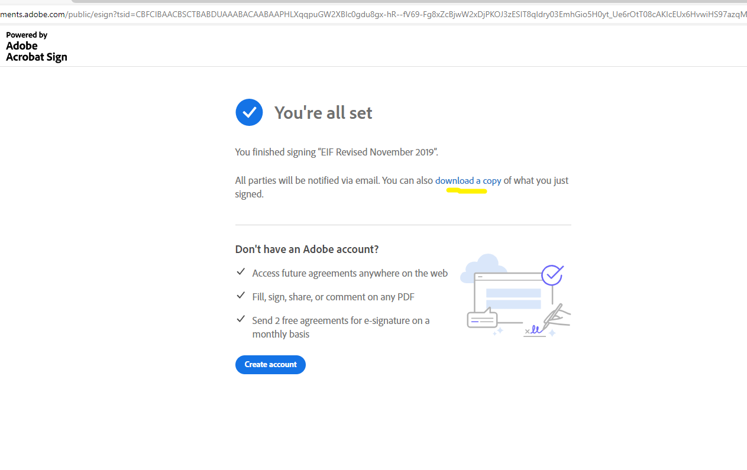

1. This is the Adobe Sign Signature we can accept. (needs the Trademark)

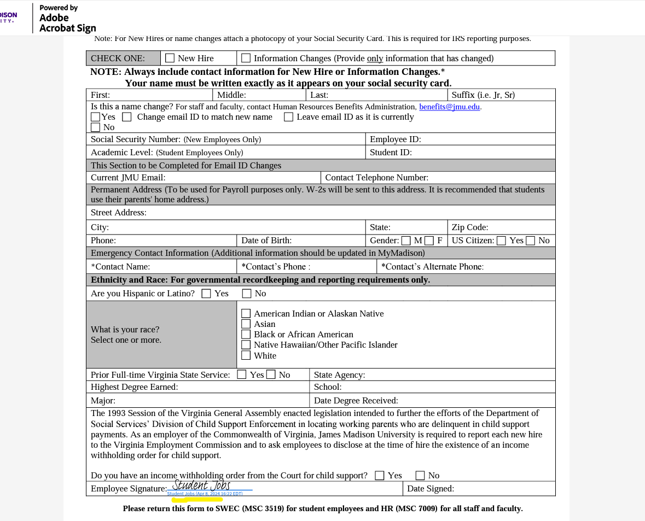

*New information: If someone selects “image” where they upload their signature, it will NOT put the blue box by the signature. **Someone must select “Type” or “Draw” in order for the blue box to appear.**

If they’ve uploaded a signature before, it might default to putting that in there automatically and not show the other options, but they can simply click in the signature box and it will bring up the regular screen like below so they can select Type or Draw.