Posting your FWS or IE Student Employee Position on PageUP

- On your Dashboard select the New job button in the New job box.
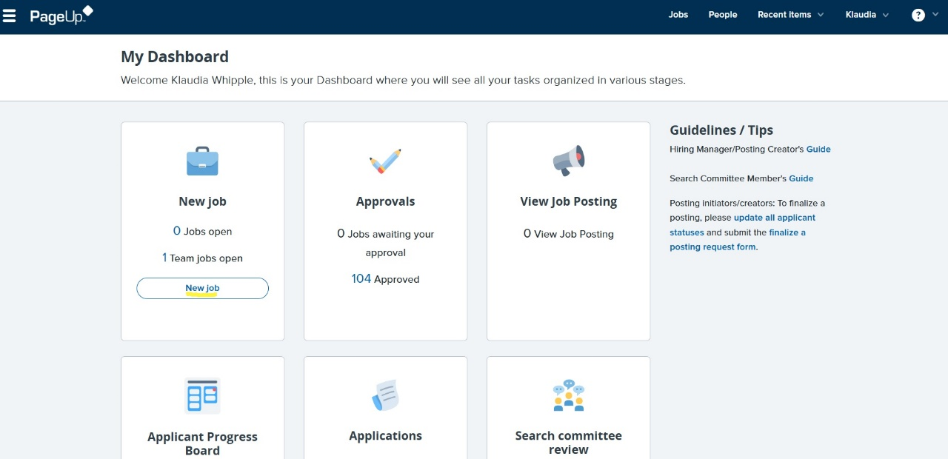
- Enter the Job Title of your position in the Position field.
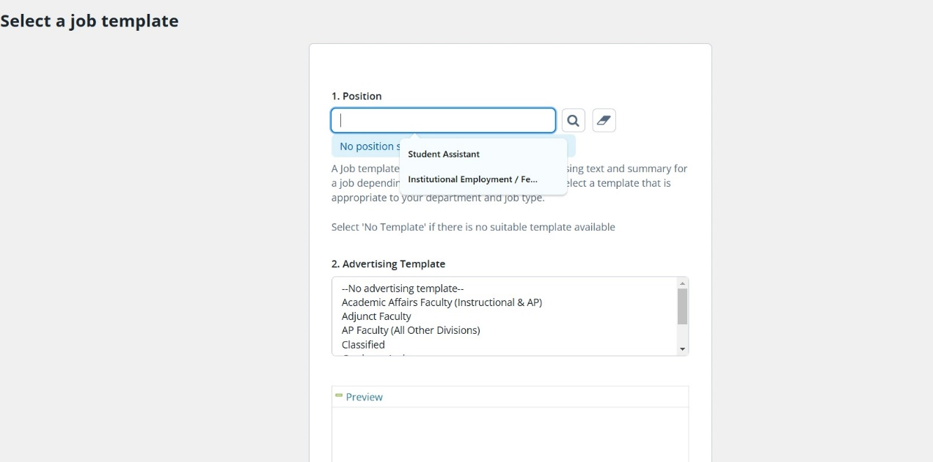
- In the pop-up box you can select a position you have in your department that matches this position, or you can just close the pop-up box.
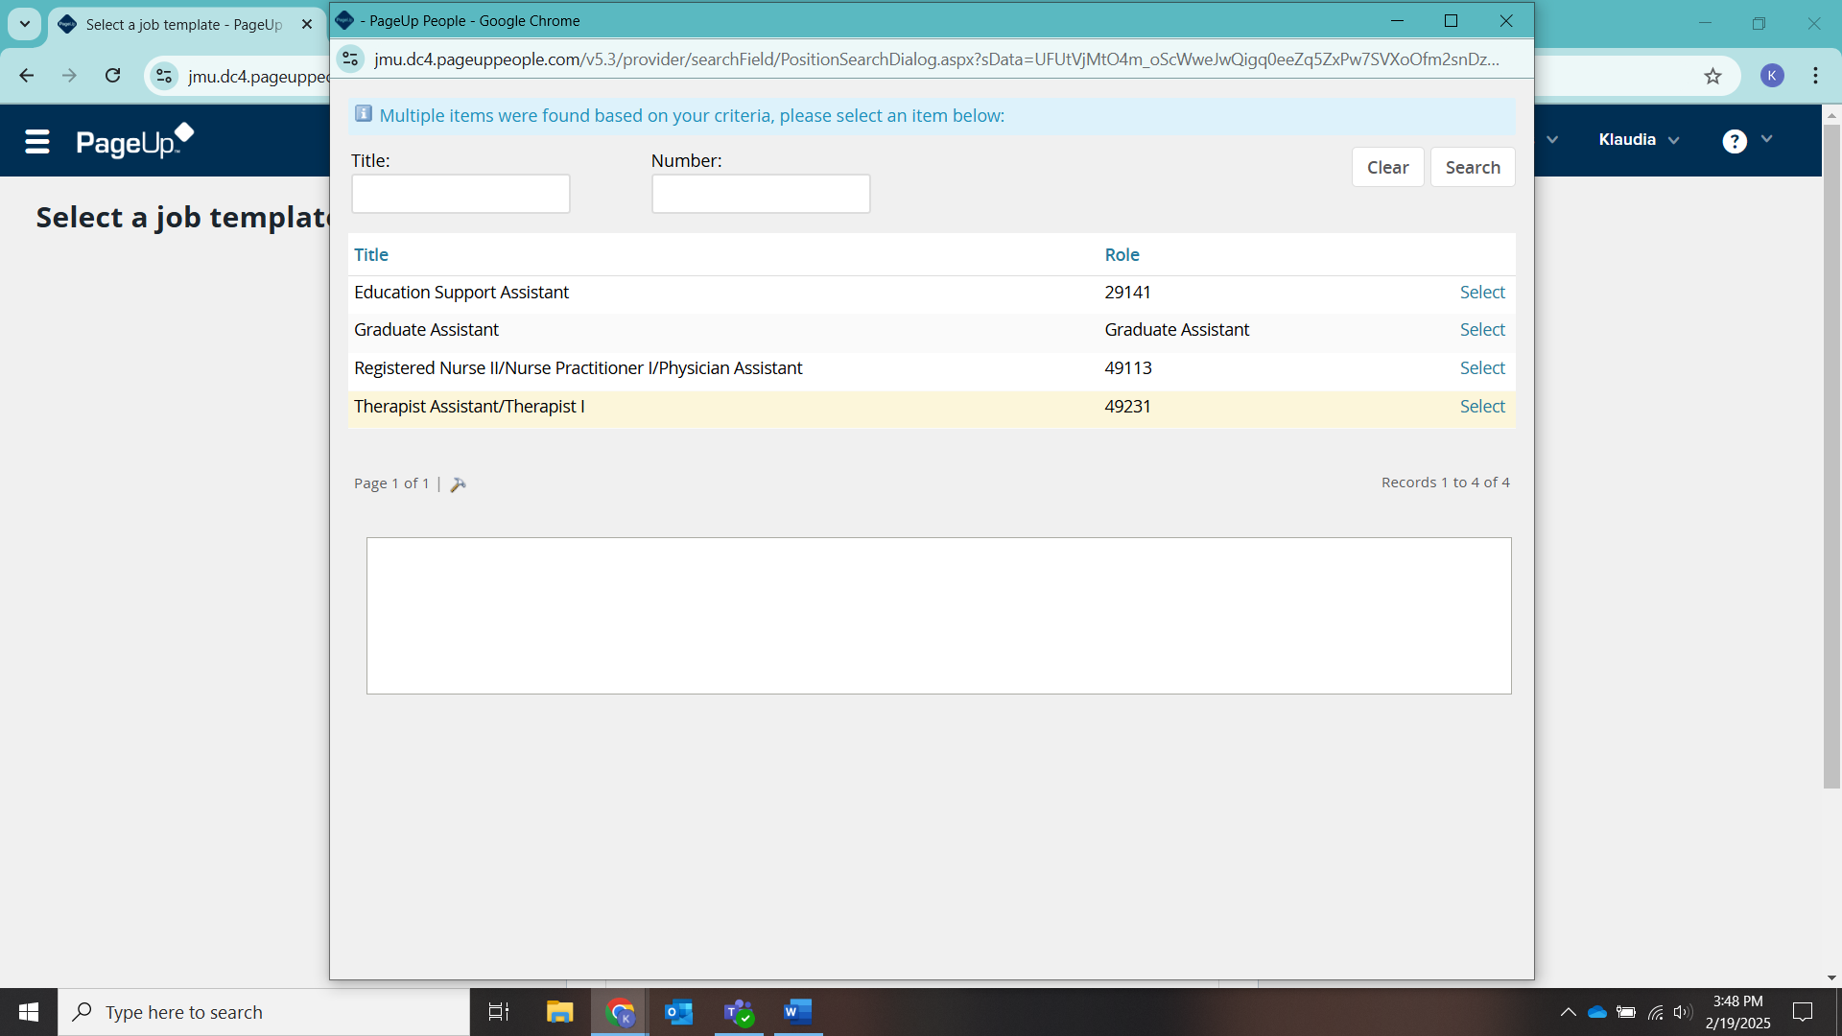
- Select Student Employment as the Advertising Template. Then select Next.
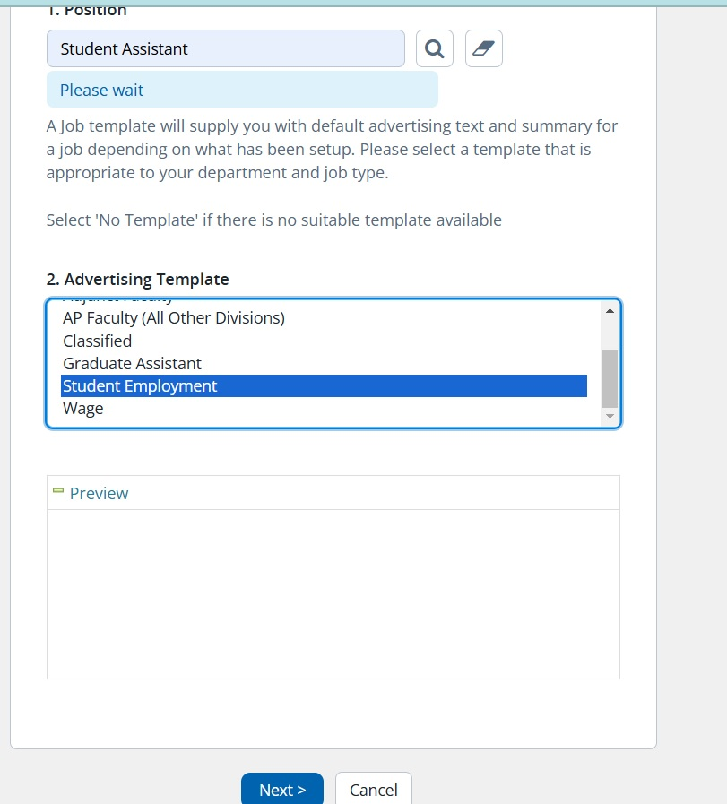
- Enter the title of your position in the Working Title field. If the position is Federal Work Study be sure to add – FWS to the end, if Institutional Employment add – IE.
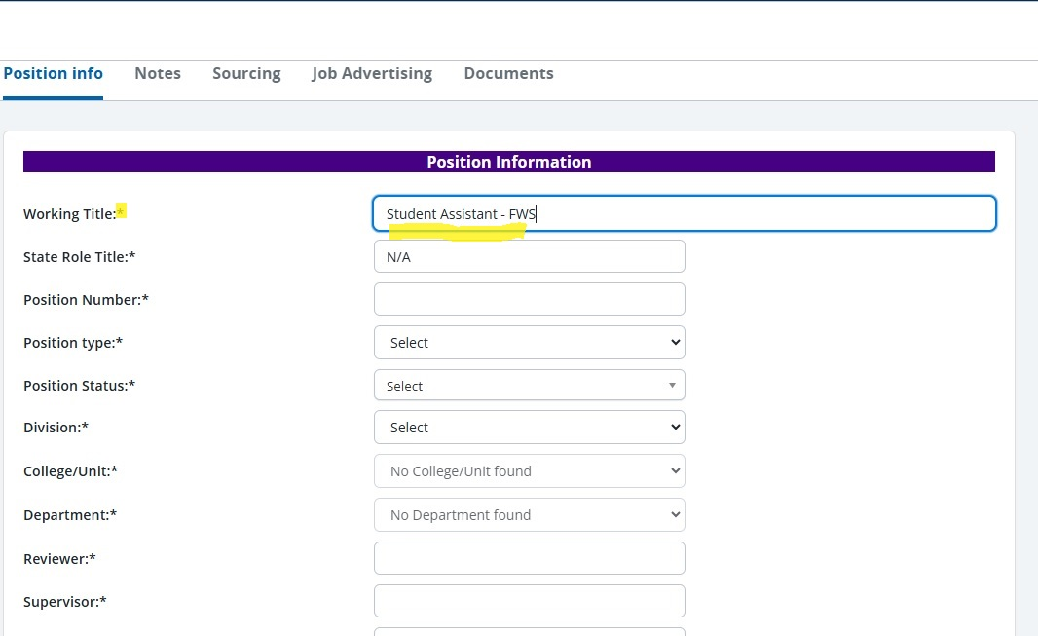
- For State Role Title enter Institutional Employment/Federal Work Study.
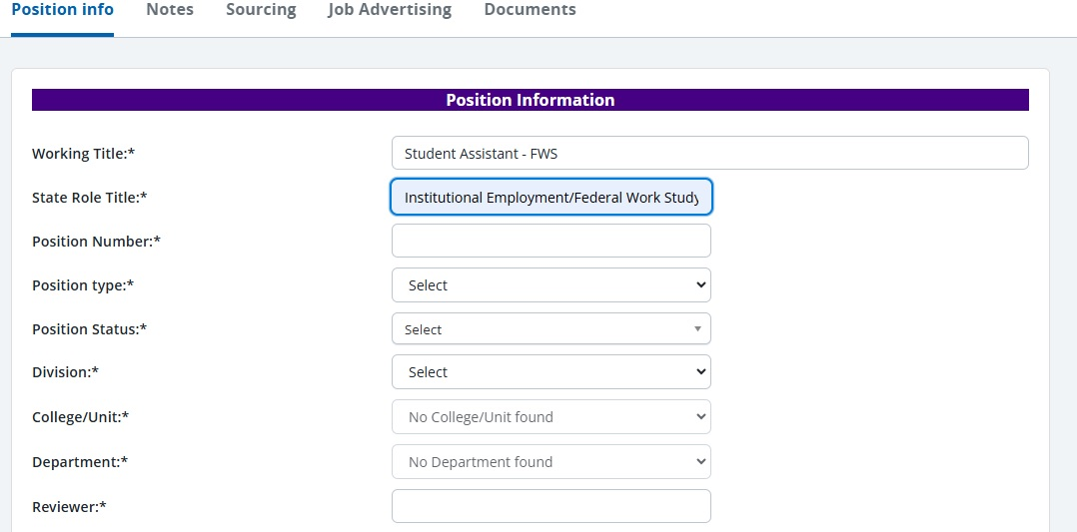
- Enter the Position Number your department has for your student position. If you do not have one or don’t know it, you can enter N/A.
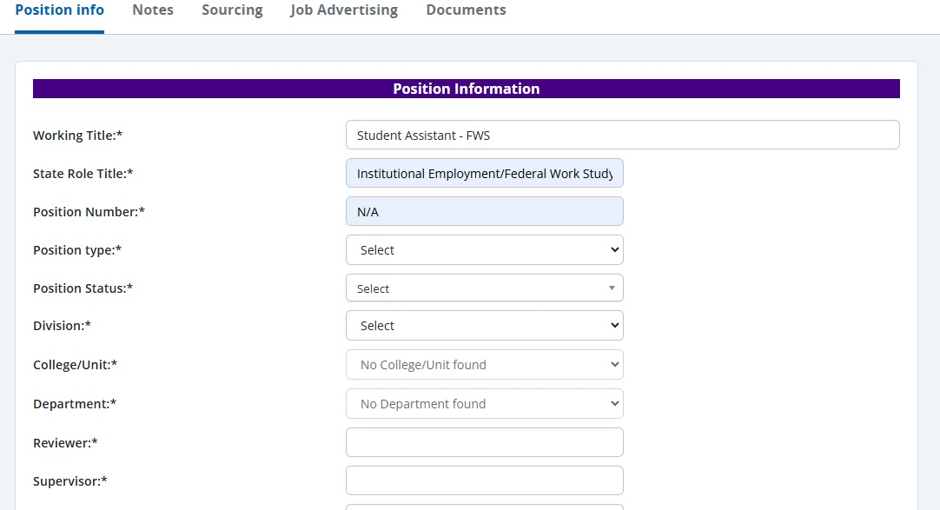
- The Position type should be Federal Work Study or Institutional Employment. (Matching the job title).
- Position Status will be Part-Time.
- Select your Division and College/Unit.
- Enter the Reviewer of this position. (Whoever oversees reviewing the applicants, can be the same as the Supervisor)
- Enter the Supervisor. (Whoever will be supervising the student)
- Check whether this is a new or replacement position.
- If this is a replacement enter the name of the student you’re replacing.
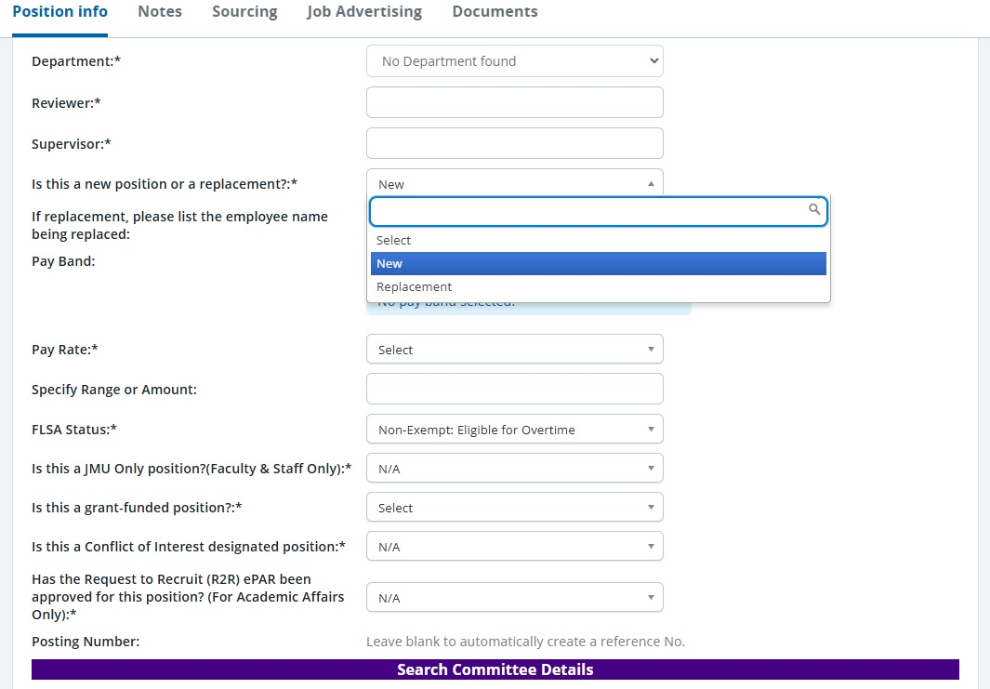
- Leave the Pay Band blank/empty since this is a Student Employment position.
- Pay Rate can be however you’d like to pay the student in this position. Hourly is the typical way.
- Specify Range or Amount must equal at least the minimum wage of $12.41/hr. (If new/entry position we recommend hourly-$12.41.)
- Leave the - FLSA Status, JMU only Position? (Faculty & Staff Only), Conflict of Interest position, and Request to Recruit (For Academic Affairs Only) - as they are.
- Check if this is a grant-funded position or not.
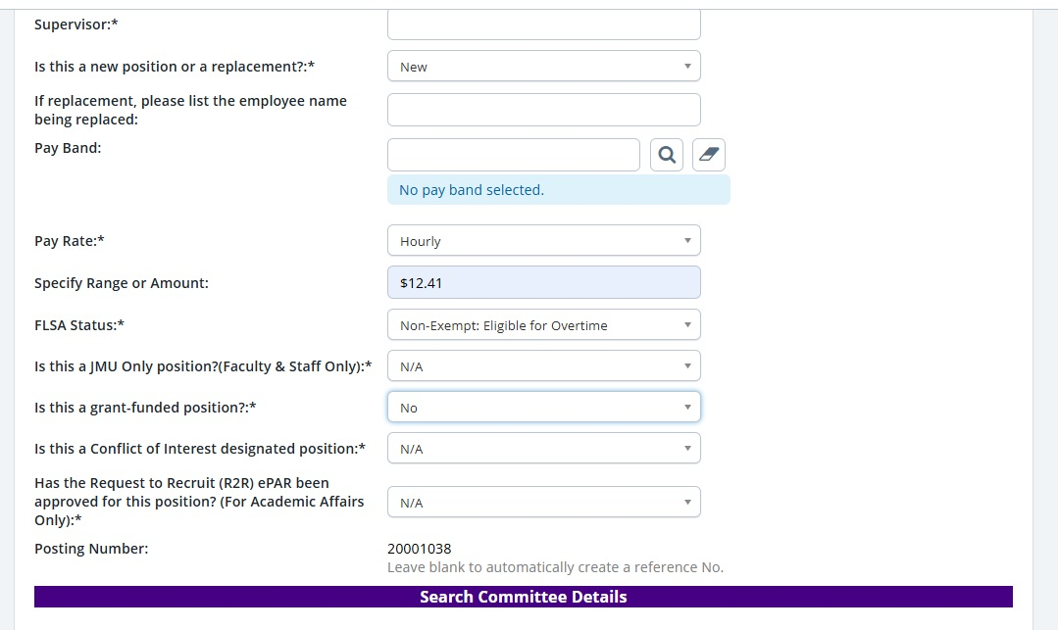
- Enter who will be the Search Committee Chair (usually the same as the Supervisor or Reviewer).
- Add any Search Committee Members (whoever will need to have access to view applications).
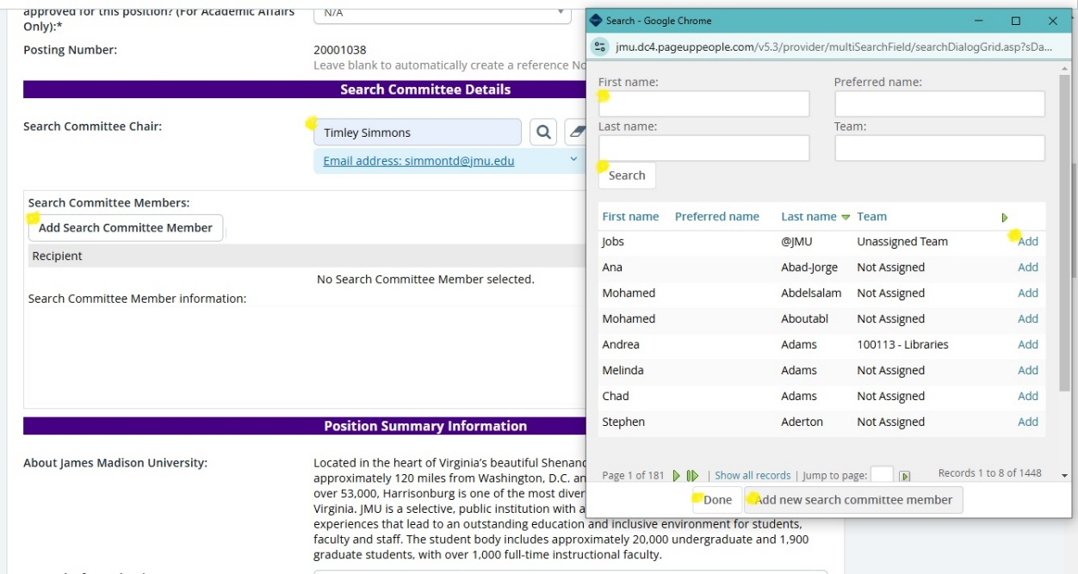
- Enter your position information in the following fields. If a FWS position be sure to enter in the Qualifications section – Must be Federal Work Study eligible.
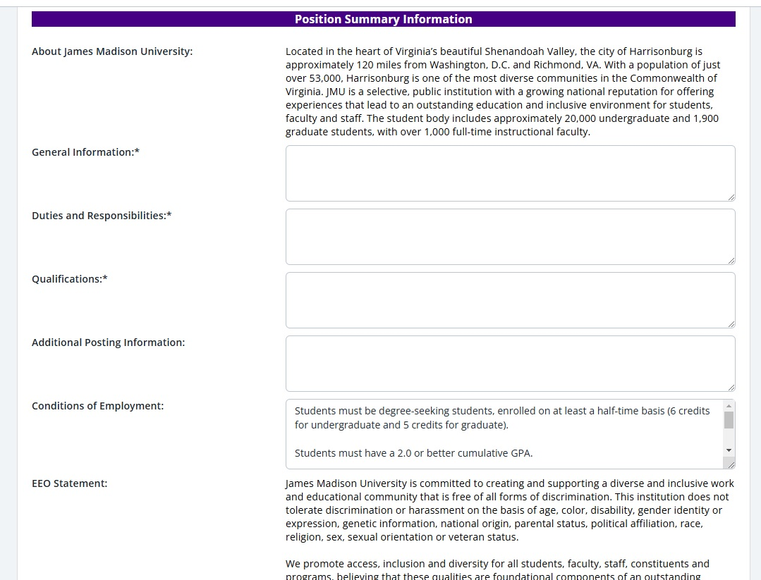
- Enter a Posting Date. This can be the same day.
- If you would like you can add a date you will begin reviewing for the Beginning Review Date sections.
- If you would like the posting to close on a certain date, enter that date for Closing Date and then check the No box for Open Until Filled. Do not change the time for the closing date.
- Or you can have the posting stay open until it is filled. Select the Yes box for Open Until Filled.
- If you would like you can enter a Proposed Starting Date.
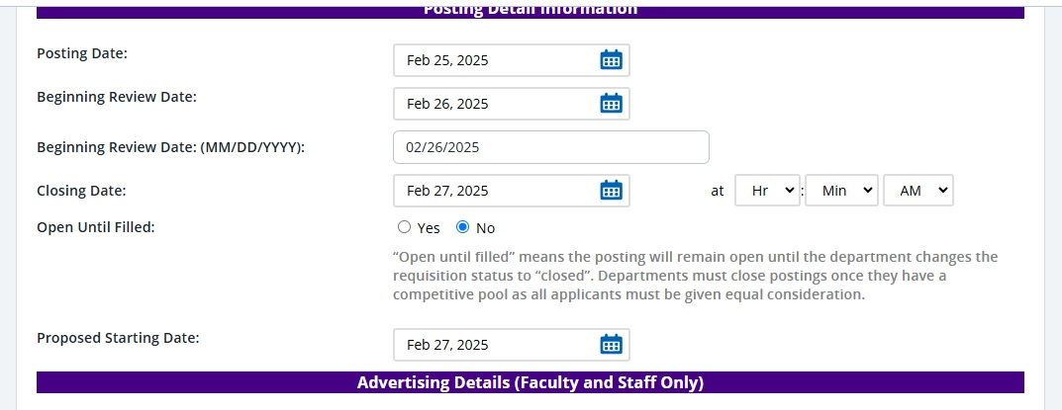
- You do not need to enter anything in the Advertising Details (Faculty and Staff Only) section.
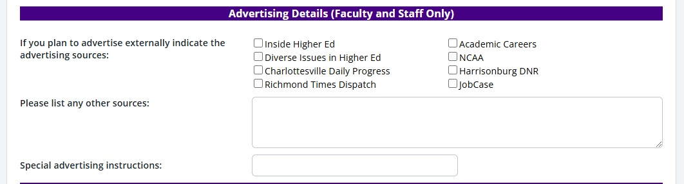
- Select Generate Description
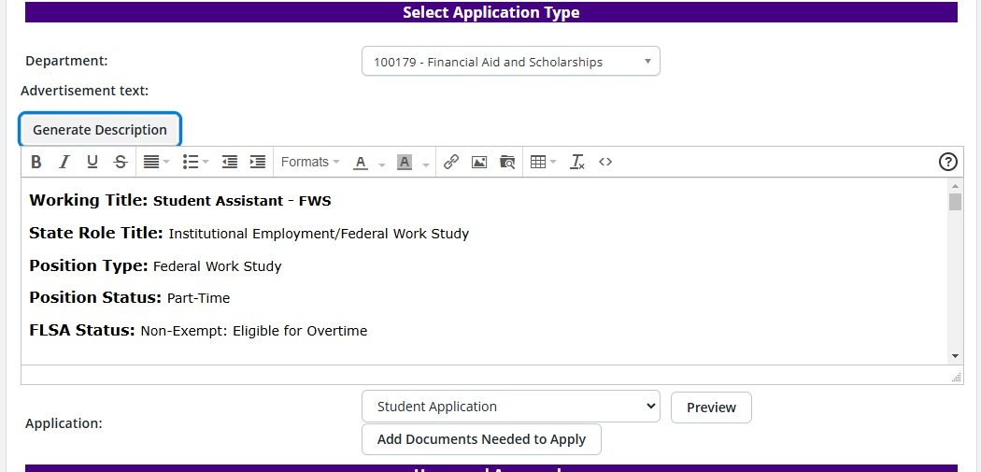
- Select the Add Documents Needed to Apply button
- In the pop-up box, Add the documents required for the application. We recommend at least having a resume and cover letter. *For FWS you must add the Financial Aid Offer Letter. Check the Selected box to see what you’ve added, then select Save and Submit.
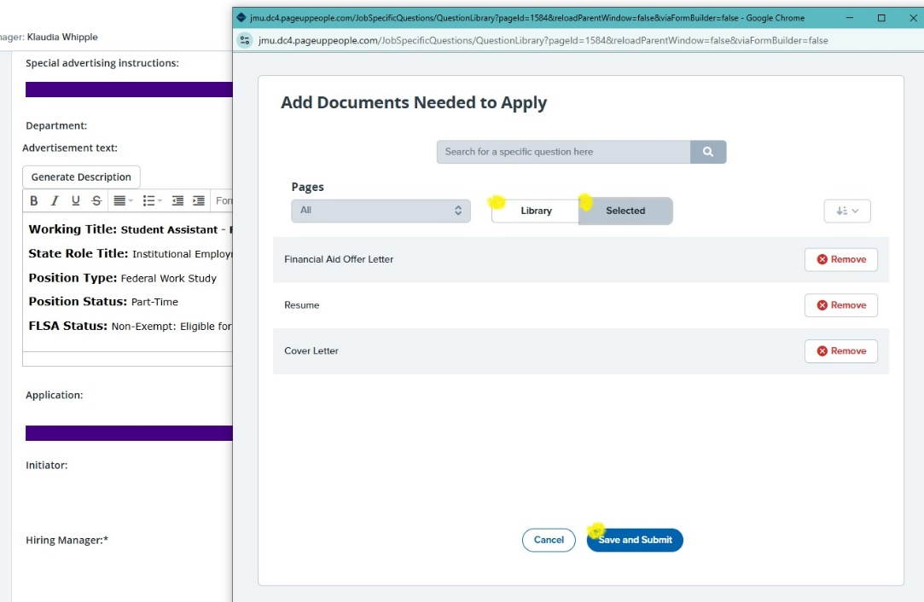
- Enter Initiator (person making this posting).
- Enter Hiring Manager (whoever is hiring, usually the same as the Reviewer/Supervisor/Search Committee Chair).
- Select the Approval process – Student Employment.
- Then select the blue Save and Submit. Finished

